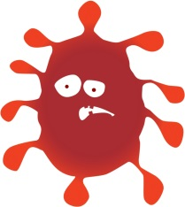
Public Health Nursing Service 0-19 (School Nursing)

Dear Parent / Guardian
Did your child miss their flu vaccination (nasal spray) in school recently? If your child is in Reception, Years 1, 2, 3, 4 or 5 and the answer to this question is Yes, or you have changed your mind and you would now like your child to have the vaccine, please contact School Nursing on the number below.

Please ring 01425 891162 to arrange to attend an urgent catch-up clinic if your child is in Reception, Years 1, 2, 3, 4 or 5 and they have not had the vaccine this academic year.
We have had an unprecedented response for catch up clinic appointments and the telephone line is extremely busy. Please leave a message on the ansaphone, stating your contact number clearly.
Calls will be returned within 3 working days.

Yours faithfully,
Public Health Nursing Service 0-19 (School Nursing)

