**Maths -**This half term we are focussing on Fractions. The children need to be able to:

 -count up and down in tenths; recognise that tenths arise from dividing an object into 10 equal parts and in dividing one-digit numbers or quantities by 10

-recognise, find and write fractions of a discrete set of objects: unit fractions and non-unit fractions with small denominators

-recognise and use fractions as numbers: unit fractions and non-unit fractions with small denominators. Recognise and show, using diagrams, equivalent fractions with small denominators

-add and subtract fractions with the same denominator within one whole

-compare and order unit fractions, and fractions with the same denominators and solve problems that involve all of the above

**English**

We will be looking at Year 3 Grammar and Spellings throughout this half term, as we write diary entries as a Roman soldier, and newspaper articles reporting the movement of the empire…

-spell words that are often misspelt

- increase the legibility, consistency and quality of their handwriting

-in non-narrative material, using simple organisational devices

-discussing writing similar to that which they are planning to write in order to understand and learn from its structure, vocabulary and grammar and proofread for spelling and punctuation errors

This half terms topic is the Romans! We will be looking at how their empire expanded and what made them a successful civilisation. We will explore their inventions and how they have helped to shape Britain in ways we still recognise today.

**Science**

We will be looking at all things to do with plants. Including: How they grow, what environment is the best place for them to grow and naming parts of a plant!

Romans

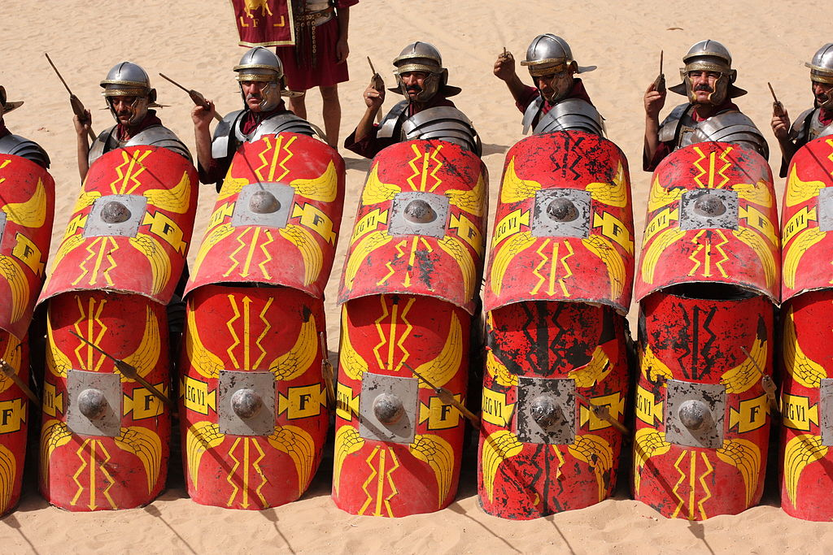

**Art**

We will be looking at the impressive mosaics that the Romans created and the colours that they used.

**Design and Technology**

We will be creating our own Roman Shields!

**History/ Geography**

We will be looking at:

-How the Roman Empire expanded, and how Alexander the Great helped this to happen.

-The Celts VS the Romans. What happened between these two very different civilisations?

-Inventions, plots and Emperors!

**French**

We will start to focus on short, simple sentences and looking at how to use intonation to create an accent!