**English** To listen to and respond to; fiction and non-fiction texts focused around Victorian Times. Write descriptions about Victorian toys. Create a poem about Victorian times. To plan and write a story about a journey back to Victorian times. To be able to add –s / -es to make nouns plural. To know the names of letters of the alphabet and put a collection of words in alphabetical order.

Maths To count on and back in 2’s, and 10’s. To read, write, order and recognise numbers to at least 20 and partition 2 digit numbers into tens and ones. To add a single digit number to a 2 digit number within at least 20 using 10 frames and deines apparatus. To subtract a single digit number from a 2 digit number within at least 20 using 10 frames and deines apparatus. To measure length using non standard units and standard units. To be able to solve a range of simple mathematical problems and give reasons for thinking.

**Music** Listen with concentration and understanding to a range of high quality recorded music including Victorian rhymes and songs.

Explore rhythm with drums and play tuned and untuned instruments musically

**Art** To use a range of materials creatively and create a printed design.

**Design and Technology** Plan, make and evaluate a puppet (hand, stick, finger puppet).

**Phonics** Practise split digraphs; a-e, i-e, o-e, e-e.Teach alternative spellings for known phonemes**: oo, air, z, or, igh, ee, oa,**  Teach reading polysyllabic words using words with alternative pronunciations. Read and spell exception words.Read and write sentences using phonic knowledge.Write simple dictated sentences using sound knowledge.

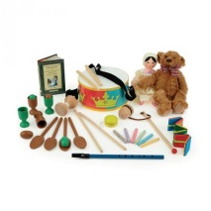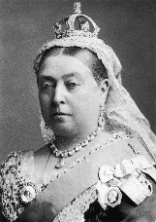

Step back in time

**Handwriting**

Practise lower and upper case letter formation using letter families and introduce lead out flick.

Practise numeral formation.

**History**

Use common words to describe phrases related to time (memory, past, event, timeline).

Identify similarities and differences between now and Victorian times.

To use artefacts to find out about the past.

To ask historical questions.