**English** To listen to and respond to; fiction texts focused around Katie Morag and the Isle of Struay. Name letters of the alphabet and use capital letters at the start of a sentence. Use non- fiction books to research coastal birds found in the UK. Write a short narrative, linking simple sentences. Write postcards, and instructions about making “porridgies”. Sequence and write the days of the week using a capital letter.

Maths To subtract using a number line. To read, write, order and recognise numbers to 20. To know number bonds for 10. To order days of the week. To recognise, name and sort 2d and 3d shapes. To be able to add and subtract a 1 digit number to and from a teen number. To be able to solve a range of simple mathematical problems.

**Music** Explore a variety of music from England, Ireland, Scotland and Wales. To use instruments to make long and short sounds and high and low sounds.

**Handwriting**

Practise lower and upper case letter formation using letter families and introduce lead out flick.

Practise numeral formation.

Amazing Places and

Spaces

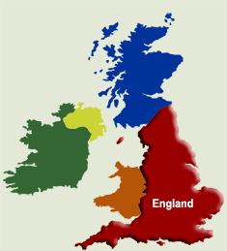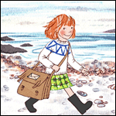

**Geography**  To use simple fieldwork and observational skills to study the geography of the school and its grounds. To use aerial photographs and plans to recognise landmarks and features. Use world maps, atlases and globes to identify United Kingdom and it’s countries as well as other countries. Name and locate and identify characteristics of the four countries and capital cities of the United Kingdom. Devise a simple map and use and construct basic symbols in a key. Know the four directions on a compass.

**Phonics** .Teach alternative grapheme for known phonemes**: ay, ou, ea, oy, ir, ue, aw, wh, ph, oe, au, ew, a-e, e-e, i-e, o-e, u-e,**  Teach reading compound words, eg, laptop, farmyard.Read and spell exception words.Read and write sentences using phonic knowledge.

Write simple dictated sentences using sounds such as “ay” that have been taught.

**Art** Look at a variety of tartans and create tartan patterns. Explore colour and texture by printing using various techniques. **Design and Technology** Plan, make and evaluate baking “porridgies”.

**Science**

To be able to identify coastal birds and how they are different to garden birds (focussed on last term).