**Geography** Focus on Puddletown; look at features and the river. Look at maps and photographs of the village. Find out where in the world Puddletown is.

**Maths**

Count, order and compare numbers to 10, 20 and beyond. Make number bonds and stories with numbers to 10. Add and subtract by using number bonds and counting on and back. Solve problems involving addition and subtraction and make number stories. Name, describe and sort 2d and 3d shapes.

**English**

To listen to and respond to; non –fiction texts about the human body, senses and garden birds. Fiction texts; Dogger, Mog and the V.E.T, and a selection of poetry.

Orally compose and ask questions to visitors.

Learn and recite poem

Write labels and sentences.

**Art** Look at ourselves and make paper sculptures of us! Create a painting using hands and feet

**Science**

Identify and name basic parts of the human body.

Name and explore using the 5 senses and identify the part of the body associated with each sense (eg, smell – nose).

Identify and name a variety of common animals, (pets and garden birds).

**History** Look at our own history from a baby to year 1. Sequence events in our own life. Ask questions to find out about the past.

**Handwriting**

Practise lower and upper case letter formation using letter families.

Practise numeral formation.

**Phonics**

To break ccvc (eg, clap) and cvcc (bank) into individual sounds and blend sounds together and apply sounds taught in year R (stairs, bright, paint).

Read and spell exception words.

Read sentences using phonic knowledge.

Write simple dictated sentences using sound knowledge.

Amazing Me!

[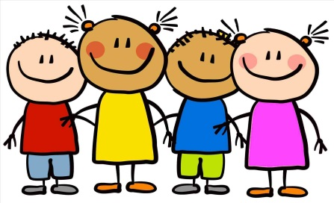](https://www.google.co.uk/url?sa=i&rct=j&q=&esrc=s&source=images&cd=&cad=rja&uact=8&ved=2ahUKEwiTkaOMi5fcAhXEvxQKHQSNDpkQjRx6BAgBEAU&url=https://trckroi.com/kids-making-craft-clipart/&psig=AOvVaw0SSqDwjIdkZD0F672ob9yy&ust=1531399694379035)