**Maths**

This half term we are focussing on place value. The children need to be able to:

- recall and use multiplication and division facts for the 3, 4 and 8 multiplication tables

-write and calculate mathematical statements for multiplication and division using the multiplication tables that they know, including for two-digit numbers times one-digit numbers, using mental and progressing to formal written methods

-solve problems, including missing number problems, involving multiplication and division, including positive integer scaling problems and correspondence problems in which n objects are connected to m objects.

**English**

We will be looking at the text ‘Pebble in my pocket.’ We will focus on the context of our writing and different grammar we can use to make our writing exciting.

-extending the range of sentences with more than one clause by using a wider range of conjunctions, including when, if, because, although

-using commas after fronted adverbials

-indicating possession by using the possessive apostrophe with singular and plural nouns

-using and punctuating direct speech

-using fronted adverbials

This half terms topic is looking at all things fossils! We will be exploring the process that creates fossils, and we will also be looking at the journey that our Earth has taken to create the landscape we now know!

**History**

We will be identifying where certain fossils have been found, and why similar ones have been found in different areas.

Fossils

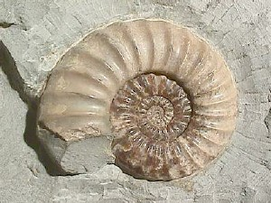

**Art**

We will be making fossil art using a range of techniques. We will also be looking at William Morris and his pattern work. The children will then design a tile and use block printing to create their own patterns.

**Science**

We will be looking at:

-Different types of rocks and how we can group them into 3 categories (Metamorphic, Igneous and Sedimentary).

-The process of fossilation.

- Where can we find fossils?

**French**

We will start to count from 0-10 in French. Then, we will look at answering simple questions such as ‘How are you?’ and ‘When is your birthday?’