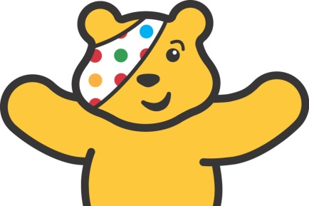
For Children in Need this year, school council would like to raise money to help. We would like you to bring in a donation and to celebrate raising money with us by wearing non-school uniform. You may like to wear Pudsey colours. This might be yellow to match Pudsey Bear, or it might be blue, green or red to match Pudsey’s eye patch. You might also have different Children in Need items such as Pudsey ears that you wish to wear. Whatever you wish to wear on Friday 16th November, we hope that you will join us in raising money.

Additionally, during our meeting, School Council recognised how fortunate we are and that there are many children who are not as fortunate as us. School Council have suggested that any toys and books that children at Puddletown First School no longer need, could be donated to charity. If this is something you feel you want to join in with, and have toys (non-electrical) and books that you no longer use, then we will be collecting them all of next week and taking them to a charity shop.

Many thanks and we look forward to seeing you on Friday for our non-uniform day.

School Council

Harry, Charlotte, Arthur, Sofia, Isaac, Betty, William and Scarlett - Lily

