**Maths**

This half term we are focussing on place value. The children need to be able to:

-add and subtract numbers mentally, including:

* + 1. a three-digit number and 1s
    2. a three-digit number and 10s
    3. a three-digit number and 100s

-add and subtract numbers with up to 3 digits, using formal written methods of columnar addition and subtraction

-estimate the answer to a calculation and use inverse operations to check answers

-solve problems, including missing number problems, using number facts, place value, and more complex addition and subtraction.

**English**

In English this half term, we are focussing on non-fiction writing and looking at how we can display information in an engaging way for our readers.

-participate in discussions, presentations, performances, roleplay/improvisations and debates.

-identifying how language, structure, and presentation contribute to meaning

-spell further homophones

- use the first 2 or 3 letters of a word to check its spelling in a dictionary

The children will start to write more independently and to go back through and improve their work.

This half terms topic is looking at skeletons. We will be looking at the importance of having a skeleton and how different animals and creatures have adapted theirs for different purposes.

**Handwriting**

-We will be looking at our tall letters- b,d,f,h,j,k and l. We will practising joining these into words and how to form them correctly whilst writing in English.

Skeletons

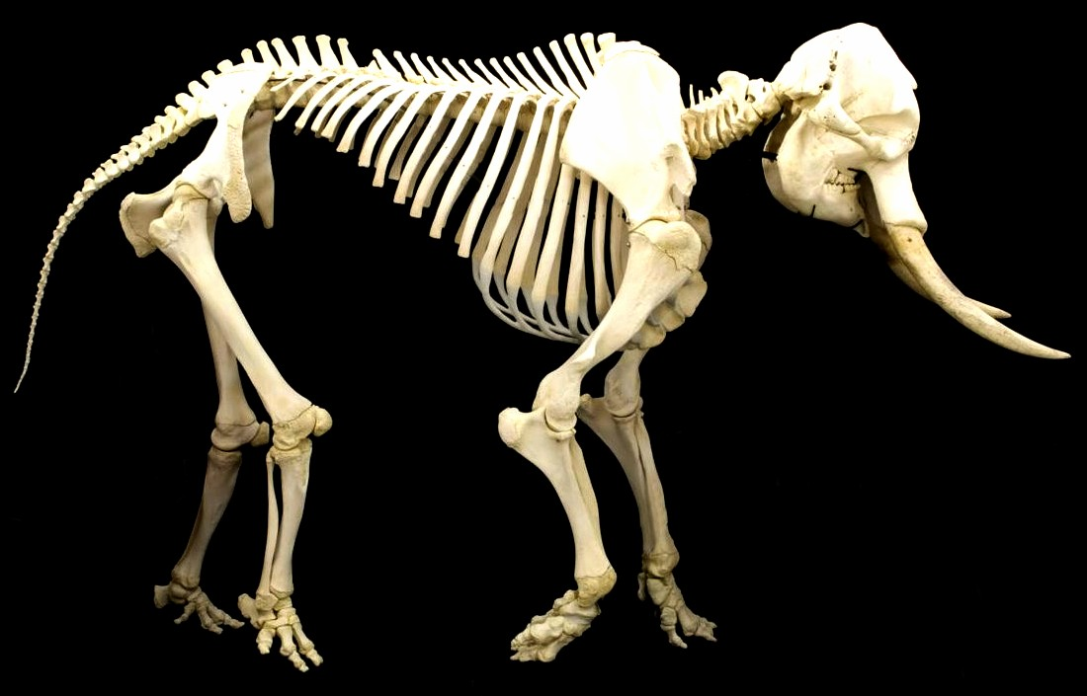

**Art**

We will be exploring art from around the world.

**Design and Technology**

We will be making dancing skeletons, and there will be a focus on DT in our home learning this half term!

**Science**

We will be looking at:

-Different types of skeletons (endoskeleton, exoskeleton and hydrostatic skeleton).

-The role and function of both our skeleton and specific bones.

-Different types of joints and muscles.

**French**

We will recap looking at basic phrases. Then will we start to form basic sentences.

‘Bonjour! Ca Va?’