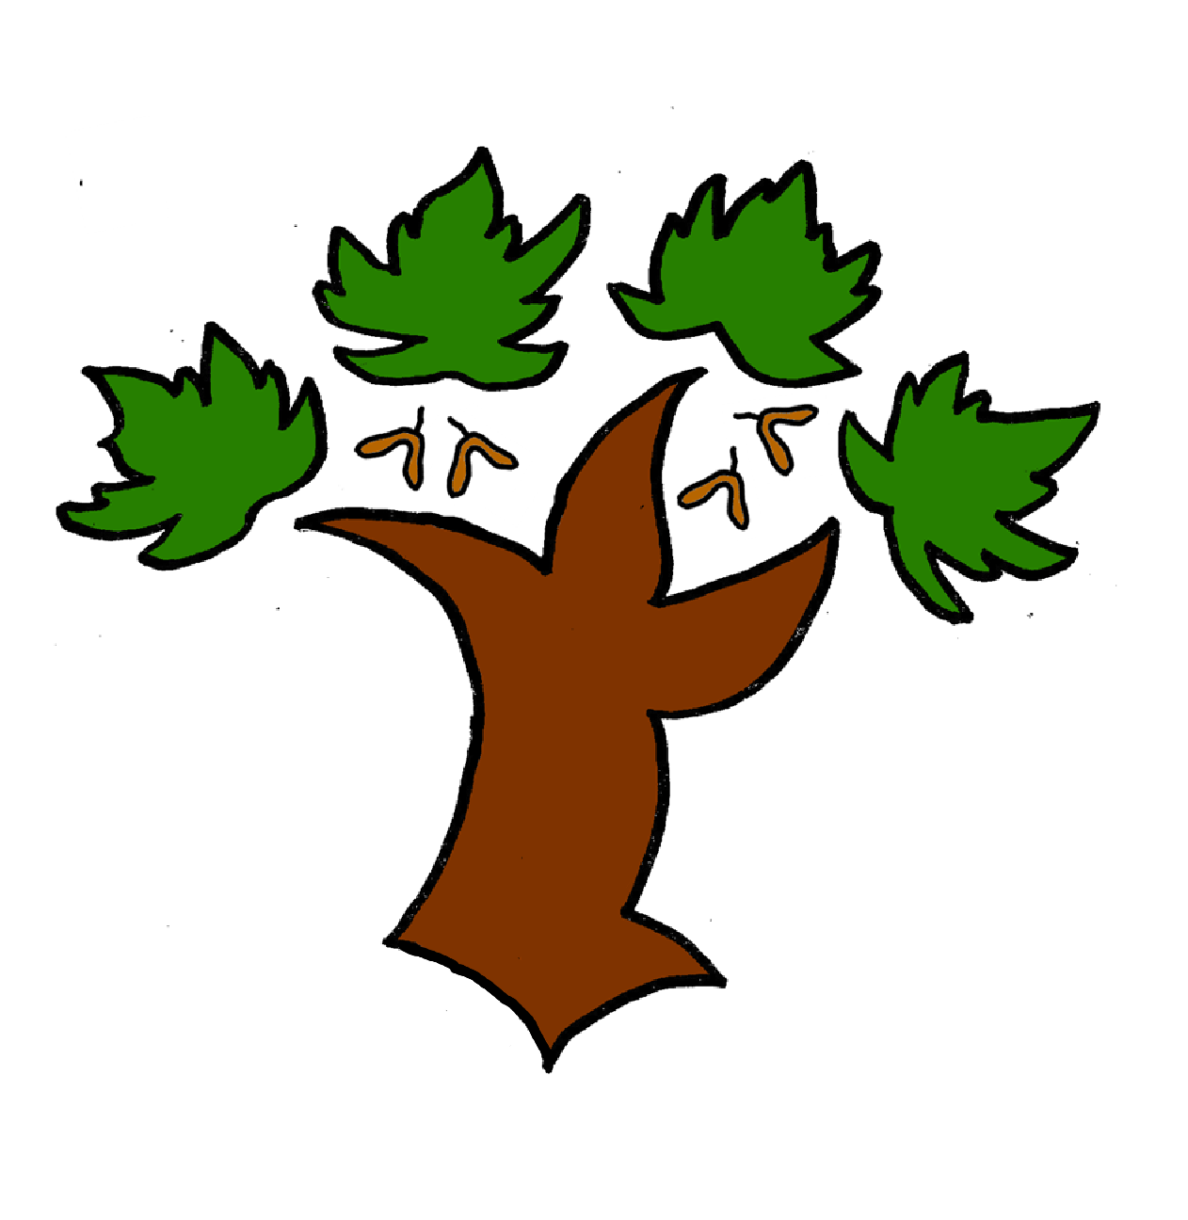
Puddletown First School
Writing – Achieving Mastery

At Puddletown First School we understand the National Curriculum to be a mastery curriculum. We believe to show mastery of the English writing curriculum children need to be able to demonstrate key skills or concepts independently. What constitutes independent writing has been defined and agreed across GTAT under the following principles;
Writing is likely to be independent if it:
- emerges from a quality text, topic, visit, or curriculum experience, in which pupils have had a range of opportunities to explore and discuss what is to be written about
- enables pupils to apply their learning independently, possibly with an element of choice, for example writing from the perspective of a chosen character
- has been independently edited and / or redrafted by the pupil. This may be in response to self, peer, or group evaluation
- is produced by pupils who have independently drawn on classroom resources such as dictionaries, thesauruses, word banks, classroom displays, books or websites for support and ideas
- is informed by clear learning objectives and limited success criteria which are not over detailed and do not over-aid pupils
Year 2
- Use full stops, exclamation and question marks to mark the end of a sentence. Accurate use of a capital letter at the start of a sentence
- Ensure that there are accurate spaces between words
- Use the past and present tense accurately
- Spell using accurate grapheme choices
- Form letters correctly with consistent size and shape
- Spell the Y2 exception words correctly – use a word mat or dictionary to self check and edit
- Self check and edit word to ensure punctuation is accurate and improve writing – ie through the addition of adjectives
- Use expanded noun phrases
- Spell some contraction words
- Use subordination accurately ie when, if , that, because
- Use coordination words ie or, and ,but

Mastery is the achievement of these skills and concepts, other elements within the National Curriculum we have defined as requiring coverage not mastery. Children that show understanding of the key skills and concepts beyond mastery are deemed to be working at greater depth

