**Maths**

This half term we are focussing on place value. The children need to be able to:

-add and subtract amounts of money to give change, using both £ and p in practical contexts

-identify horizontal and vertical lines and pairs of perpendicular and parallel lines.

- recognise angles as a property of shape or a description of a turn

-draw 2-D shapes and make 3-D shapes using modelling materials; recognise 3-D shapes in different orientations and describe them

- identify horizontal and vertical lines and pairs of perpendicular and parallel lines.

**English**

We will be looking at the text ‘Ug-Stone Age Boy Genius’ by Raymond Briggs.

-reading books that are structured in different ways and reading for a range of purposes

-discussing writing like that which they are planning to write in order to understand and learn from its structure, vocabulary and grammar

-using and punctuating direct speech

- increase the legibility, consistency and quality of their handwriting

- use further prefixes and suffixes and understand how to add them

This half terms topic is Stone Age to Iron Age! We are going to explore the journey humans took from being nomads to settlers. We will look at how their inventions still inspire today’s living.

**Geography**

We will be looking at how the nomadic tribes of the Stone Age moved in accordance with weather changes and land changes.

Stone Age to Iron Age

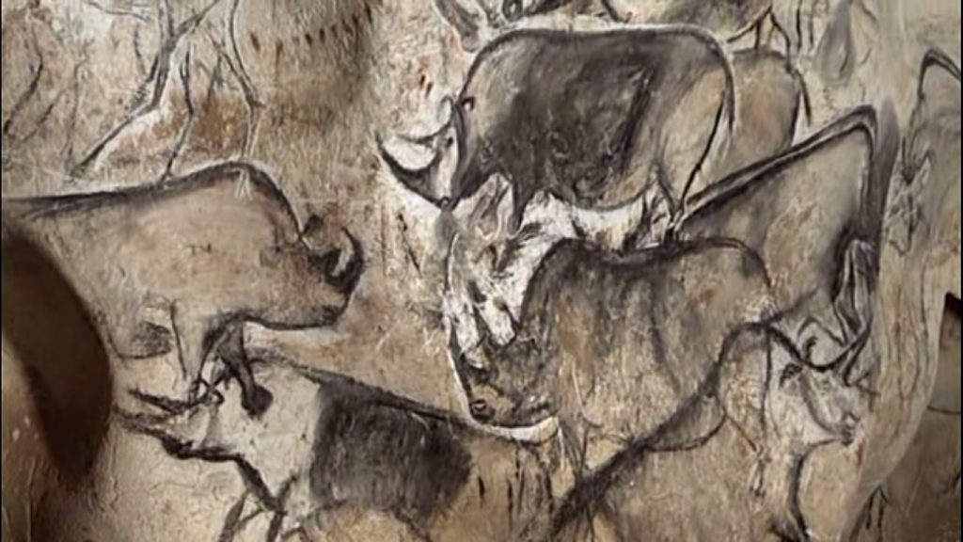

**Art**

We will be looking at cave paintings and creating art using paper mediums.

**Design and Technology**

We will be researching, designing and creating our round houses.

**History**

We will be looking at:

-Culturally significant places such as Stonehenge and Skara Brae.

-How farming came about and why.

-How did these civilisations affect the way we live now and how did they impact upon our environment?

**French**

We will start to count from 0-10 in French. Then, we will look at answering simple questions such as ‘How are you?’ and ‘When is your birthday?’