**Maths**

This half term we are focussing on place value. The children need to be able to:

-count from 0 in multiples of 4, 8, 50 and 100; find 10 or 100 more or less than a given number

-recognise the place value of each digit in a 3-digit number (100s, 10s, 1s)

-compare and order numbers up to 1,000

-identify, represent and estimate numbers using different representation

-read and write numbers up to 1,000 in numerals and in words

-solve number problems and practical problems involving these ideas.

**English**

We will start by looking at a volcano fact file and then writing our own:

-organising paragraphs around a theme

- proofread for spelling and punctuation errors

-in non-narrative material, using simple organisational devices

We will then look at the text ‘Escape from Pompeii’.

-in narratives, creating settings, characters and plot

-using conjunctions, adverbs and prepositions to express time and cause

-using fronted adverbials

This half terms topic is looking at all things volcanoes! We will be exploring our world and looking at its destructive nature, but we will also look at how this amazing phenomenon also creates places for farming and unique habitats for animals!

**Handwriting**

-Practising the joining of our vowel letters both separately and in words.

-Ensuring that our pencil grip is comfortable for longer writing pieces.

Volcanoes

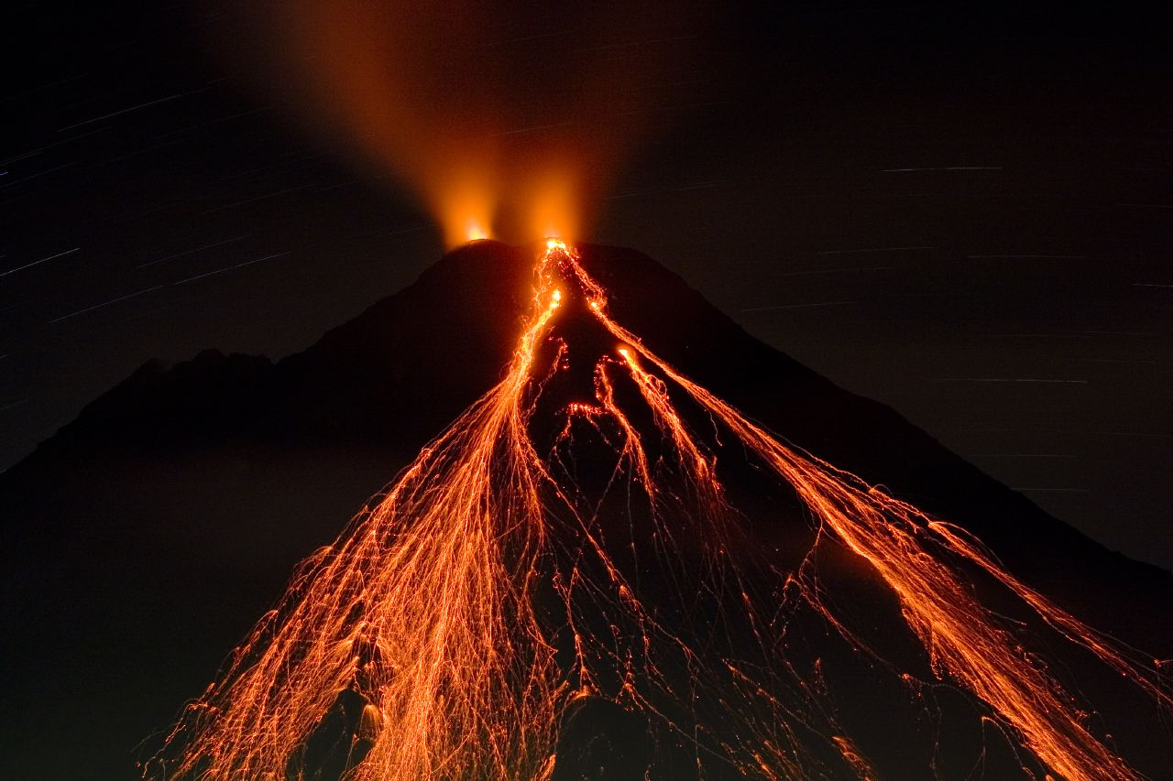

**Art**

We will be using different mediums to create volcano pictures and looking at different materials to create texture.

**Design and Technology**

We will be making a volcano model and then exploding it using vinegar and bicarbonate soda!

**Geography**

We will be looking at:

-Types of volcanoes and how they form.

-Famous volcanoes and where they are located.

-Ring of fire- Why is this of importance?

-People’s lives and how they are affected by volcanoes.

-7 continents and 5 oceans- where are they?

**French**

We will be looking at saying Hello, Hi, Goodbye, and Good Evening. We will then move onto looking at feelings.