**Maths**

Puddletown First School has adopted the Singapore Maths approach to maths teaching as its central theme. This matches the approach to maths taken by all the first schools in the local pyramid.

**Maths No Problem: Singapore Maths**

**Singapore Maths Overview**

In 1986, Singapore was 16th out of 26 countries in the SIS study. They decided to do something about this and used 2 major reports that were circulating at the time on maths: The UK Cockcroft report and a US Study called Agenda for Action. By 1995, Singapore was the top performing country in maths and has continued this in the following years.

The learning methods are the product of research produced around the world on how children learn, by notable experts such as Jerome Bruner, Richard Skemp, Howard Gardner and Zoltan Deines. Singapore math is an amalgamation of global ideas delivered as a highly-effective programme of teaching methods and books from Reception onwards.

Howard Gardner: Work on multiple intelligences – emphasised that we should not focus on computation or memorisation because we are not good at these.

In Singapore, children start learning in Year 1 (our Year 2). They would be taught in classes of 30 pupils (in Yr 1&2) and usually 40 pupils (in Yr 2&3). There is no TA.

Children attend school for a morning or an afternoon.

**Core Essentials**

***The 3 core essentials are:***

* visualisation
* looking for patterns
* making decisions

***The CPA approach using in Singapore Maths:***

1. Concrete
2. Pictorial progression through these stages
3. Abstract

***The 3 levels of understanding:***

1. Enactive: acting things out (a problem in reception where you explain that there are 7 children and 4 go away, how many children will be left? Children find the answer by acting it out)
2. Iconic: representing with something else e.g. pictorial (to work out the above problem, children could use cubes or draw pictures)
3. Symbolic: children use mathematical symbols (e.g. 7-4= )

|  |
| --- |
| **Of particular importance for struggling mathematicians and to learn new concepts:**  CONCRETE → PICTORIAL → ABSTRACT |

The teacher is constantly assessing when the child makes the link from concrete to pictorial. The teacher models constantly in teaching the pictorial when teaching the concrete. Lessons may have objectives to move from one to the other.

There is an emphasis on problem solving and comprehension, allowing students to relate what they learn and to connect knowledge Careful scaffolding of core competencies of:

* visualisation, as a platform for comprehension
* mental strategies, to develop decision making abilities
* pattern recognition, to support the ability to make connections and generalise
* Emphasis on the foundations for learning and not on the content itself so students learn to think mathematically as opposed to merely reciting formulas or procedures.

There is a firm belief in Singapore maths that you do not move onto a new concept/idea until children have learnt what you are teaching. Particularly in early teaching, they may spend a few weeks on a concept/idea. The importance is that you cannot build onto another concept until you have mastered this one, otherwise you are building onto shaky foundations.

The Singapore maths is a spiral curriculum: next year you will build on what you have learnt this year. We will continue to use the skills we have learnt through the year

|  |
| --- |
| How you learn is as important that the content |

When teaching a new concept, children are taught through concrete teaching (an activity) that allows them to learn the concept for themselves in a practical task, using their own language and knowledge to explain their learning. The concrete tasks will incorporate other ideas/earning and often include pictorial representation of their ideas/looking for patterns etc..

New language is then taught in the following lessons. The following lessons will focus more on pictorial and moving to abstract when ready.

Most lessons begin with an anchor task – a problem solving task that will last about 20 minutes of the lesson. Then there will be some guided work/practice before some individual work/practice that is often assessed.

In the lessons, there’s a lot of asking the children to explain. “Do you understand what your friend is saying?”. This phrase is used a lot. “If you do, that’s good. If you don’t, that’s ok”.

Streaming is discouraged, particularly in primary lessons. There would be one objective for all. Everyone is learning the same thing. However, you would expect ALL children to be able to understand perhaps one way and other children to extend to learn more than 1 way etc.. Finding patterns and generalisations etc.. are the ways in which UA are stretched in concepts. There is no differentiation by content, just by understanding and moving from concrete to pictorial to abstract and looking for patterns, alternate ways etc...

You are a facilitator. Explain in your own words to your partner. How do you know?

Children need the time and space to learn. We want creative thinkers not children that have learned procedures by rote.

Every anchor lesson must have:

1. A clear learning objective

2. A thinking skill behind it

3. Every task must cater for L/U ability

**Number Bonds**

Start with concrete in a practical task. E.g. sharing 10 objects between two cups or two plates.

Any time numbers are split up into concepts, Singapore maths uses the same pictorial representation:

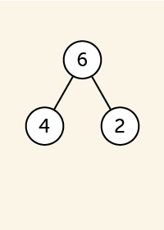

This part/part=whole concept is used right from Reception.

Number bond diagrams is used later on for addition/subtraction

etc... Any time that numbers are split up!

6+5: would be represented as 6+4+1=10+1=11

[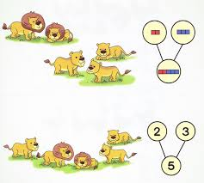](http://www.google.co.uk/url?sa=i&rct=j&q=singapore+maths+number+bonds&source=images&cd=&cad=rja&uact=8&docid=QtGDBYySDo5CyM&tbnid=m7T2b3cXPc4mAM:&ved=0CAUQjRw&url=http://singaporemathsource.com/tag/number-bonds/&ei=iqBCU9mkHdKy7Abp-IHYCQ&psig=AFQjCNE5xKeXzYud-97sw-wKeFafh3N4fw&ust=1396961743946093)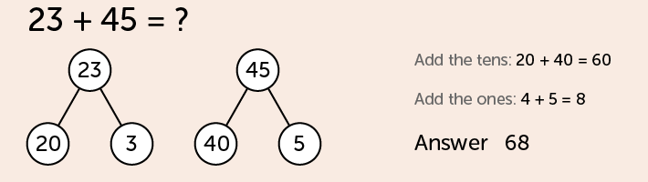

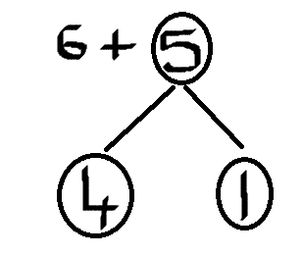

**Use of the 10 Frame**

Again, this begins practical e.g. egg cartons. The 10 frame is the basis of much of the number work and understanding of place value. It leads on to addition/subtraction etc.. and other concepts. It is used because you are never 1 or 2 from **5** or **10**.

[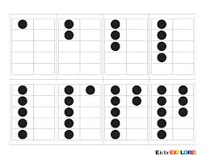](http://www.google.co.uk/url?sa=i&rct=j&q=singapore+maths+10+frame&source=images&cd=&cad=rja&uact=8&docid=ldIXQBE7AvKQWM&tbnid=V4ozx3ZEyc7axM:&ved=&url=http://eisforexplore.blogspot.com/2012/09/ten-frame-war.html&ei=8KBCU-y3Nqev7AaayIDAAQ&psig=AFQjCNHBuDcZ0_RFo0xsU2iqhOxLZliqsg&ust=1396961905344614)

3 is 2 less than 5.

9 is 1 less than 10 etc...

Children discover the concept of place value through the 10s frame. As you move on to teens numbers there would be a completed 10s frame and another part completed 10s frame.

They would add teens and teens numbers using this.

19 + 16. Through the 10s frame, and self discovery, they would see that this is the same as 20+15 etc... They learn themselves through doing.

|  |  |
| --- | --- |
|  |  |
|  |  |
|  |  |
|  |  |
|  |  |

|  |  |
| --- | --- |
|  |  |
|  |  |
|  |  |
|  |  |
|  |  |

|  |  |
| --- | --- |
|  |  |
|  |  |
|  |  |
|  |  |
|  |  |

|  |  |
| --- | --- |
|  |  |
|  |  |
|  |  |
|  |  |
|  |  |

They move onto base 10 blocks and from pictorial to symbolic.

It is often the conventions(procedures/computational strategies) that children struggle with in maths rather than the understanding.

|  |  |
| --- | --- |
| 2 | 5 |
|  |  |
|  |  |
|  |  |
|  |  |
|  |  |

Children move on to more pictorial when ready.

They would also see it in many different ways e.g.

money, bars of 10s etc...

**Place Value**

Their groundings in place value support them in the four number operations which is why a strong grounding in place value is essential.

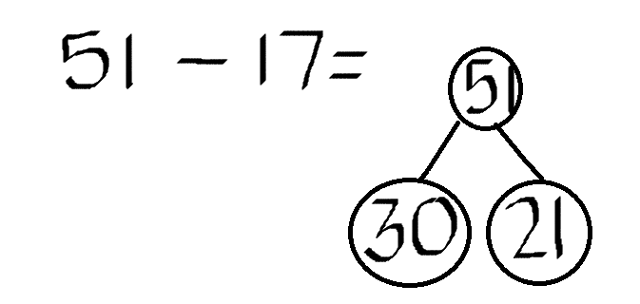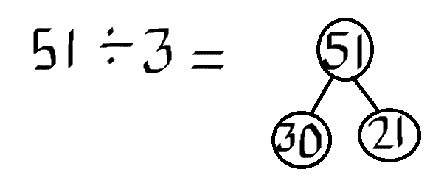

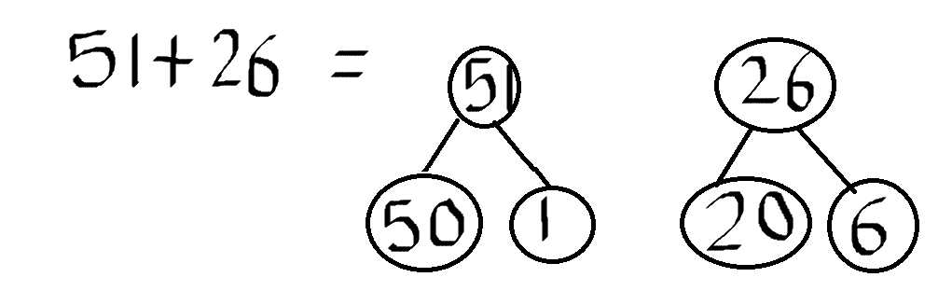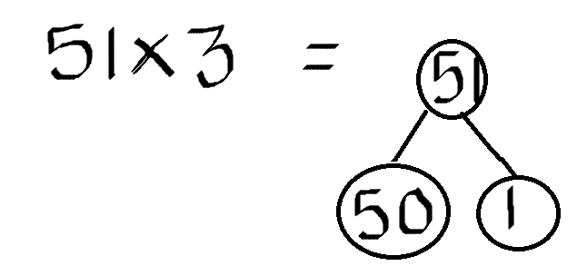

You are teaching the children relational understanding of numbers.

You are teaching them to make their decisions in number bonds than teaching them the procedures.

You will eventually teach procedures but children then understand them and understand when to use them. (197 + 254).

**Fractions**

Start with concrete in many different ways. Show me a half. How do you know? Let children find out themselves why it is a half in practical situations. Don’t tell children that two halves = a whole. Children need to discover this for themselves. They will then remember it.

Show in different ways, using shapes, pictures etc...

**SUMMARY**

**Teach to Mastery:**

* Spent time before moving on
* Spend a consolidated amount of time on one topic (e.g. numbers to 1000 for weeks and weeks)
* Spend a consolidated amount of time on 1 question in each lesson (anchor question for 20 minutes)

**4 questions to ask when preparing your lesson plan:**

1. What will they learn (may be different from what you teach!)

2, How will I know if they have learnt it? (measure/journals to record pictorially)

3. What if they can’t get it?

4. What if they already have it? (How to extend)

**Zoltan Dienes**

1. Play (informal-concrete)

2. Structured learning (formal/ teacher support/this is how you could write your ideas etc...)

3. Practise (independent)

**Core Essentials**

1. Metacognition (explain why you know what you know)

2. Visualisation

3. Generalisation

4. Number sense

5. Communication (children learn from observing other children that can do it)

**Richard Skemp**

1. Relational Understanding: can do that and understand why they are doing it and why it works

2. Instrumental Understanding: show that you can come up with the right answer by following a set of procedures.

**Bar Method**

|  |  |
| --- | --- |
| Capture1.JPG | Capture2.JPG |
| Capture3.JPG | Capture4.JPG |

|  |  |
| --- | --- |
| Capture5.JPG | Capture6.JPG |
| Capture7.JPG | Capture8.JPG |



  
  
  

