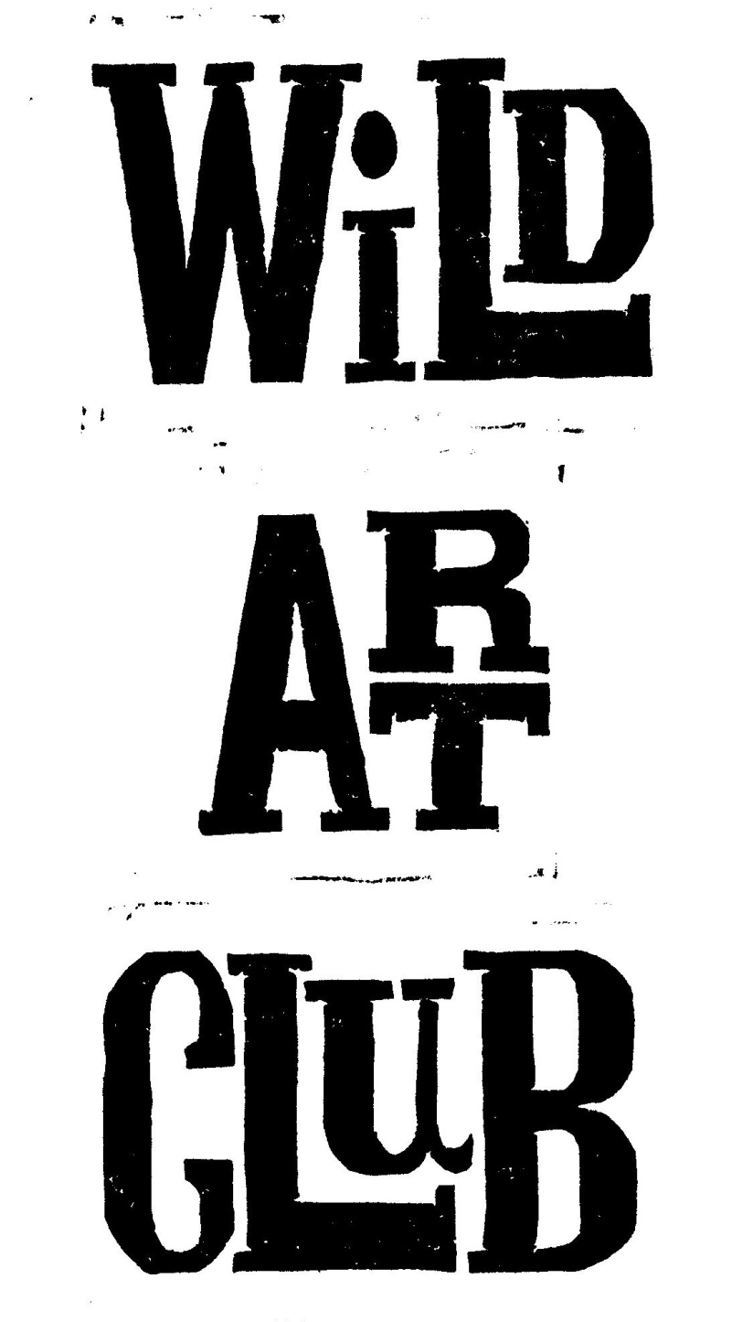 Please speak to me if there is a problem and

**Follow the club on Instagram to see the children’s artwork:**

**Wild Art Club. Spring Term 2019.**

Enjoy Exploring Wildlife at School, through hands-on experience and Art & Craft activities, with Maggie Spratt.

**Wild Art Club will run for 11 sessions** **during the Spring Term** **on Wednesdays,** **from 3:15pm to 4:45pm.**

**Starting on 16th Jan – 3rd April, at a cost of £55 each.**

**Open to Years 1, 2, 3 & 4.**

Please make sure that your child has an old painting shirt to wear, as sessions can get messy! A healthy snack is welcome, no sweets please. Good Behaviour is Expected At All Times. Please be on time to collect children at the end of each session. **Cost for the term is £55.00, payable by cheque, cash or BACS to Mrs M Spratt Sort Code 202662 Account Number: 60703338 Payable as a single payment of £55 by 16th Jan, or two payments of £25 to be paid by the 16th Jan & £30 to be paid by the 27th Feb 2019.** Consent Form & Payment must be returned by 16th Jan 2019 to ensure your child’s place, & numbers may be restricted depending on availability of adult helpers. Please detach and return form to School Reception. Please speak to me if there is a problem and I will try to accommodate you: [mrspratt@hotmail.co.uk](mailto:mrspratt@hotmail.co.uk) 01258-837927/07929-832662



**Wild Art Club Spring Term 2019.**

Name of Child………………………………………………………………………………………………Year..………………………………

Email Address………………………………………………………………………………………………………………………………………

Contact Telephone No…………………………………………………………………………………………………………………………..

Please state if your child has any relevant medical conditions/allergies……………………………………………..………….

I am happy for my child to be photographed for publicity………..………………………………………………………..………

I enclose payment of £55.00 for the whole term or £25.00 for first ½ Spring Term 2019 / £30.00 for 2nd ½ Spring Term 2019. (Please circle as applicable).

Signed…………………………………………..………Print Name……………………….....…………..……..…….Parent/Guardian