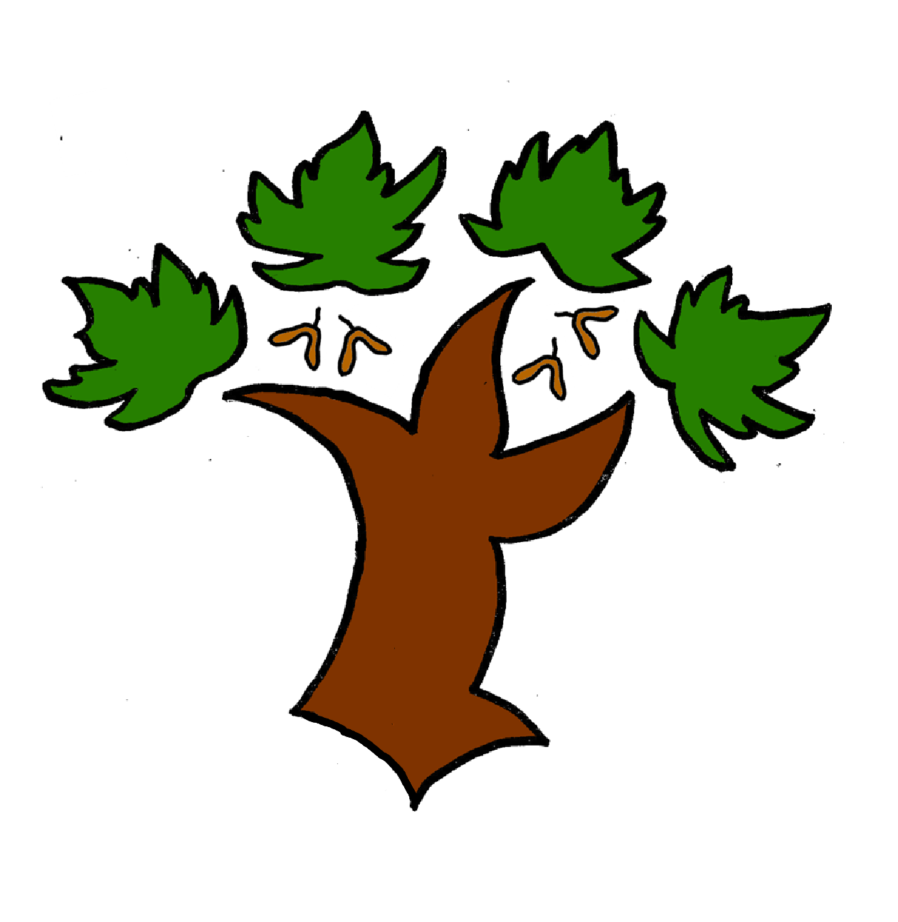
Puddletown First School
Y 1 Reading – Achieving Mastery

At Puddletown First School we understand the National Curriculum to be a mastery curriculum. We believe to show mastery of the English reading curriculum children need to be able to demonstrate key skills or concepts independently and consistently.
Mastery is the achievement of these skills and concepts, other elements within the National Curriculum we have defined as requiring coverage not mastery. Children that show understanding of the key skills and concepts beyond mastery are deemed to be working at greater depth
- Discuss the significance of the title
- Discuss the significant events within a fiction text
- Be able to answer question that require information from the text read
- When reading a text check it makes sense and self correct errors
- Be able to link their own experiences with the text being read
- Read words containing _s, _es, _ing, _ed, _er, _est
- Read contraction words eg I’m, I’ll, we’ll
- Read words with more than one syllable
- Read accurately the Y1 exception words
- When reading pause at a full stop
- Read words containing 40+ phonemes including alternative graphemes eg ow/ou
- Achieve the standard set in the Phonic Assessment
- Complete phase 5 for reading

Some children may go on to show an understanding and confidence in reading that indicated a greater depth of learning. These children would demonstrate all of the mastery skills and concepts but would also;
- Be able to predict what might happen next based on what they have read so far
- Make some inferences on the basis of what is being said and done

