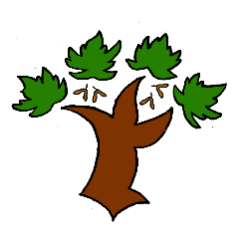
Puddletown First School
Y4 Writing – Achieving Mastery

Curriculum Intent:
- To have an enjoyment of writing both as a communication and as a creative process
- To write with clarity and accuracy
Speaking and listening
- To use discussion as a tool for learning
- To be able to speak with clarity and articulation including publically

At Puddletown First School we understand the National Curriculum to be a mastery curriculum. We believe to show mastery of the English writing curriculum children need to be able to demonstrate key skills or concepts independently. What constitutes independent writing has been defined and agreed across GTAT under the following principles;
Writing is likely to be independent if it:
- emerges from a quality text, topic, visit, or curriculum experience, in which pupils have had a range of opportunities to explore and discuss what is to be written about
- enables pupils to apply their learning independently, possibly with an element of choice, for example writing from the perspective of a chosen character
- has been independently edited and / or redrafted by the pupil. This may be in response to self, peer, or group evaluation
- is produced by pupils who have independently drawn on classroom resources such as dictionaries, thesauruses, word banks, classroom displays, books or websites for support and ideas
- is informed by clear learning objectives and limited success criteria which are not over detailed and do not over-aid pupils
Year 4
- Punctuation is accurate including direct speech and the possessive apostrophe
- Commas are used after a fronted adverbial
- Paragraphs are used to organise the writing
- Spelling of most of the Y3/4 wordlist is correct – this may be the consequence of self checking and editing
- When self editing and checking mistakes in spelling or punctuation can be identified and corrected
- When self editing the effectiveness of their writing or the writing of others they can self assess and offer suggestions for improvement
- There is evidence of a range of sentence types and sentences with more than one clause and a range of conjunctions
- Handwriting is joined and consistent in form and size

Mastery is the achievement of these skills and concepts, other elements within the National Curriculum we have defined as requiring coverage not mastery. Children that show understanding of the key skills and concepts beyond mastery are deemed to be working at greater depth.

