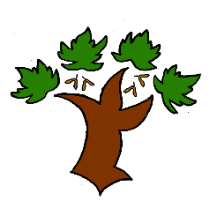
Puddletown First School
KS1 Geography – Achieving Mastery

At Puddletown First School we understand the National Curriculum to be a mastery curriculum. We believe to show mastery of the Geography curriculum children need to be able to demonstrate key skills or concepts independently. The principle behind achieving mastery in the children being able to demonstrate an ability ‘to think like a Geographer’
Curriculum Intent:
- Develop contextual knowledge of the location of significant places understanding some of the human and physical features
- Understand how the human and physical features of an area link and may change over time
- Have competency in key geographical skills
Key knowledge required for mastery:
- Name and locate the 7 continents and 5 oceans
- Name, locate and identify the 4 countries of the UK and their capitals
- To identify the hot and cold places in the world in relation to the equator and polar regions
In addition mastery is the achievement of these skills and concepts
- To identify and describe seasonal and daily weather and weather patterns in the UK
- To identify and describe key human and physical geographical similarities and differences between an area of the UK and a non European area
- To use world maps and atlases to identify the UK, other countries, continents and oceans as they are being studied
- To use compass directions
- To use aerial photographs to recognise landmarks and key human and physical features
- To be able to observe and describe the key human and physical features in the local area (school/village)
- To be able to devise a simple map with a basic key

Key vocabulary
City, town, village, factory, farm, house, office, port, harbour, shop, country, capital (city)
Seasons and weather, beach, cliff, coast, forest, hill, mountain, sea, ocean, river, soil, valley, vegetation
North, south, east, west
Equator, North Pole, South Pole

Human Physical Fieldwork

