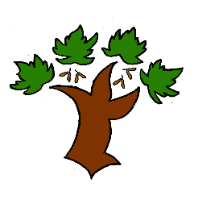
Puddletown First School
Y3 Writing – Achieving Mastery

Curriculum Intent:
- To have an enjoyment of writing both as a communication and as a creative process
- To write with clarity and accuracy
Speaking and listening
- To use discussion as a tool for learning
- To be able to speak with clarity and articulation including publically
At Puddletown First School we understand the National Curriculum to be a mastery curriculum. We believe to show mastery of the English writing curriculum children need to be able to demonstrate key skills or concepts independently. What constitutes independent writing has been defined and agreed across GTAT under the following principles;
Writing is likely to be independent if it:
- emerges from a quality text, topic, visit, or curriculum experience, in which pupils have had a range of opportunities to explore and discuss what is to be written about
- enables pupils to apply their learning independently, possibly with an element of choice, for example writing from the perspective of a chosen character
- has been independently edited and / or redrafted by the pupil. This may be in response to self, peer, or group evaluation
- is produced by pupils who have independently drawn on classroom resources such as dictionaries, thesauruses, word banks, classroom displays, books or websites for support and ideas
- is informed by clear learning objectives and limited success criteria which are not over detailed and do not over-aid pupils
Year 3
- The use of capital letters, full stops, question and exclamation marks, commas for lists and apostrophes for contraction is accurate
- There is some evidence of paragraphs being used to organise ideas
- There is some evidence of headings and subheadings being used in non narrative writing
- In narrative writing description is used for setting and character
- Sentences are orally rehearsed for meaning and accuracy
- Spelling of common words and exception words in the Y3 list is accurate. Spelling patterns and phonic knowledge is applied consistently
- There is evidence of joined handwriting in independent writing

Mastery is the achievement of these skills and concepts, other elements within the National Curriculum we have defined as requiring coverage not mastery. Children that show understanding of the key skills and concepts beyond mastery are deemed to be working at greater depth

