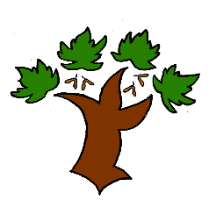
Puddletown First School
Y1 Writing – Achieving Mastery

At Puddletown First School we understand the National Curriculum to be a mastery curriculum. We believe to show mastery of the English writing curriculum children need to be able to demonstrate key skills or concepts independently. What constitutes independent writing has been defined and agreed across GTAT under the following principles;
Writing is likely to be independent if it:
- emerges from a quality text, topic, visit, or curriculum experience, in which pupils have had a range of opportunities to explore and discuss what is to be written about
- enables pupils to apply their learning independently, possibly with an element of choice, for example writing from the perspective of a chosen character
- has been independently edited and / or redrafted by the pupil. This may be in response to self, peer, or group evaluation
- is produced by pupils who have independently drawn on classroom resources such as dictionaries, thesauruses, word banks, classroom displays, books or websites for support and ideas
- is informed by clear learning objectives and limited success criteria which are not over detailed and do not over-aid pupils
Year 1
- Use a full stop to mark the end of a sentence and a capital letter at the start of a sentence
- Rehearse aloud what they are going to write
- Use exclamation and question marks
- Ensure that there are accurate spaces between words
- Spell phonetically plausible words using the phonic blends within Y1
requirements
- Use ed for past tense
- Use and to join sentences
- Form most letters correctly – especially descenders
- Spell all key exception words correctly
- Use a word mat to spell and check exception words
Mastery is the achievement of these skills and concepts, other elements within the National Curriculum we have defined as requiring coverage not mastery. Children that show understanding of the key skills and concepts beyond mastery are deemed to be working at greater depth
Exception words that must be spelt correctly to achieve mastery
the said are no house my I you do like was to your love he of some put push she be so pull be come go full

Exception words that must be spelt correctly to show greater depth
Today there friend says where school were once here our ask

