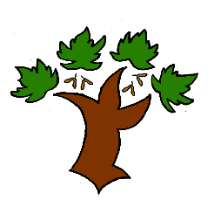
Puddletown First School
KS2 Geography – Achieving Mastery

At Puddletown First School we understand the National Curriculum to be a mastery curriculum. We believe to show mastery of the Geography curriculum children need to be able to demonstrate key skills or concepts independently. The principle behind achieving mastery in the children being able to demonstrate an ability ‘to think like a Geographer’
Curriculum Intent:
- Develop contextual knowledge of the location of significant places understanding some of the human and physical features
- Understand how the human and physical features of an area link and may change over time
- Have competency in key geographical skills
Key knowledge required for mastery:
- Name and locate counties principle cities within the UK
- Name, locate using maps the world’s countries
- To know the similarities and differences between a region of the UK, Europe and North or South America
- Identify the position and significance of latitude, longitude, Equator, Northern Hemisphere, Southern Hemisphere, the tropics of Cancer and Capricorn, the Arctic and Antarctic Circle
In addition mastery is the achievement of these skills and concepts
- To use maps, atlases and globes to locate countries
- To use the 8 points of a compass and grid references
- To use a map key, including an OS map key
- To identify types of settlement and land use and their impact on the environment
- To identify and describe climate zones, rivers, mountains, volcanoes, earthquakes and the water cycle. Understanding their impact on people
- To use sketch maps, graphs plans, maps etc to observe, measure and record the human and physical features in the local area

Key vocabulary
Urban, rural, industrial, agriculture, land use, economic activity, trade links, natural resources
Climate, climate zone, rivers, mountains volcanoes, earthquakes
Ordnance survey, grid reference

Human Physical Fieldwork

