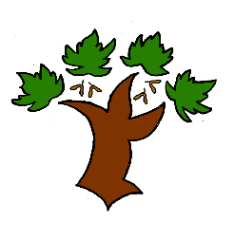
Puddletown First School
KS2 Art and Design – Achieving Mastery

At Puddletown First School we understand the National Curriculum to be a mastery curriculum. We believe to show mastery of the Geography curriculum children need to be able to demonstrate key skills or concepts independently. The principle behind achieving mastery in the children being able to demonstrate an ability ‘to think like an artist or designer’
Curriculum intent:
- Produce creative work through exploring their ideas and experiences
- To become proficient in drawing, painting, sculpture and other art and design techniques
- Evaluate and analyse creative works using the appropriate vocabulary
- Know about famous artists and understand the development of art forms
- Use a sketch book to record their ideas and observations. To use their book to revisit and review their ideas
- Develop and improve their use of art and design techniques with a range of materials
- Know about the work of famous artists, designers and architects
Artists and designers to be followed

Key vocabulary

