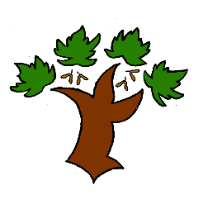
Puddletown First School
KS1 Science– Achieving Mastery

At Puddletown First School we understand the National Curriculum to be a mastery curriculum. We believe to show mastery of the Geography curriculum children need to be able to demonstrate key skills or concepts independently. The principle behind achieving mastery in the children being able to demonstrate an ability ‘to think like a scientist’
Curriculum intent:
- To develop scientific knowledge and understanding through enquiry and observation
- To carry out a scientific enquiry answering a question about the world around them employing scientific methods and processes
- Show an understanding of how some science is used in the world they live
Working scientifically
- Ask simple questions and recognise that they can be answered in different ways
- Set up simple requiring observations and measurements that help answer questions
- Use observations to suggest answers
- Identify and classify according to observable features
Living things
- Identify and name common wild and garden plants (Y1)
- Identify the basic structure of common plants (Y1)
- Know and identify common animals by name, type (reptile, mammal etc), whether they are carnivore or herbivore (Y1)
- Identify and name basic human body parts (Y1)
Materials
- To compare and sort rocks according to appearance and some properties
- Describe how fossils are formed
- Know that soil is composed of rocks and organic material
Seasonal change
- Observe changes across the 4 seasons
- Observe and describe weather associated with the 4 seasons and how the length of day changes
Key vocabulary

