Literacy and Reading:  When guided reading we will focus on decoding, prosody (reading with expression) and comprehension. Each week children will bring home a library book to share and enjoy with you and their guided reading book to  practise at home.  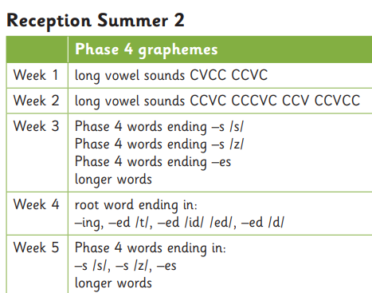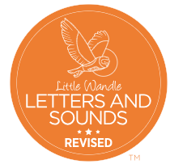  Revise all tricky words | Mathematics:  In Maths we will be using NCETM for the number aspect of our learning and the White Rose Scheme for our topic Maths.    Subitise to 5  Introduce the rekenrek.  - Automatic recall of bonds to 5 - review and assess.  - Composition of numbers to 10 - review and assess.  - Comparison- review and assess.  - Number patterns - review and assess.  - Counting - review and assess.    Sharing and grouping  Length, time, height | Understanding the World:  - With support, observe, record and talk about materials and living things. Molluscs such as snails, clams and muscles have shells to protect them.  - Name a variety of domestic and wild animals. Learn about animals including sea birds, crabs and starfish live at the sea shore.  - Identify common features for different groups of animals, including wild and domestic animals. Learning that crabs have five pairs of legs. The first pair of legs has pincers.  - Investigate rockpools and learn who they are habitats for.  - Animals eat different kinds of food, including other animals, plants or both animals and plants.  - Who lives in the ocean?  - Some animals including fish, whales, sharks and dolphins live in the seas and oceans.  - Learning about features of fishes.  - Begin to notice and talk about the different places around the world including oceans and seas. Looking after our beach.  - Holidays in the past.
Communication and Language:  Listen and respond with relevant questions, comments, or actions.  Attend to others in play.  Make comments and clarify thinking with questions.  Retell the story once they have developed a deep familiarity with the text; some as exact repetition and some in their own words.  Speak in well-formed sentences with some detail.  Use new vocabulary in different contexts.  Use past, present, and future tenses in conversation with peers and adults. Use conjunctions to extend and articulate their ideas.  Our Literacy will be based on the following books: The seasaw by Tom Percival. This is a story about a little girl who loses her special teddy bear while on a trip to the beach. The sea realises what has happened and tries to help the bear get back to the little girl. Will the girl and her bear ever be reunited? Up and Down by Oliver Jeffers This is a story about a boy and his best friend, the penguin. They do everything together, but there is something the penguin really wants to do on his own. Penguin wants to fly. Eventually, he finds a way to fly, but will he enjoy it? | Reception Summer Term 2 | PSHE:  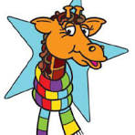  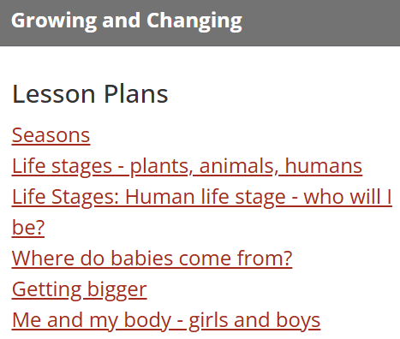
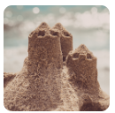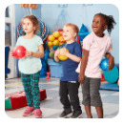
On the Beach Move It
 | Physical Development:  Confidently and safely use a range of large and small apparatus indoors and outside, alone and in a group.  PE: Mr Treble  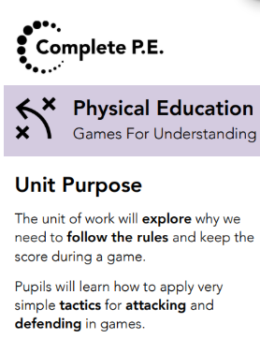  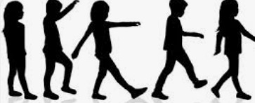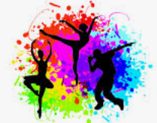 | RE:  Emmanuel Project  How can we care for our wonderful world?  This unit lays foundations for an understanding that Christians believe humans are a special part of God’s creation and have a God-given responsibility to care for the  incredible world we all share.  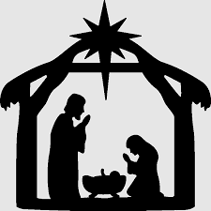  
Expressive Arts and Design:
- Beach art. Use digital devices to take digital images or recordings of their creations to share with others.
- Sounds of the sea.
- Sandy paint.
- Use primary and other coloured paint and a range of methods of application.
- Create collaboratively, share ideas and use a variety of resources to make products inspired by existing products, stories or their own ideas, interests or experiences. to the water tray.

In Music we follow the programme Down there under the sea and Bow Bow Bow Belinda. This term we will be learning about structure, timbre, active listening, tune moving in step, soundscrap, beat and accompaniment.



