Literacy and Reading:  When guided reading we will focus on decoding, prosody (reading with expression) and comprehension. Each week children will bring home a library book to share and enjoy with you and their guided reading book to  practise at home.  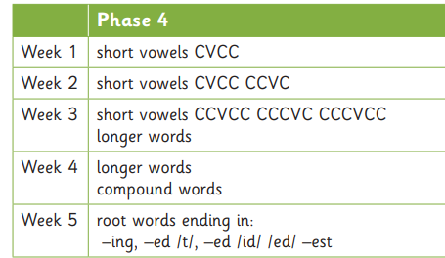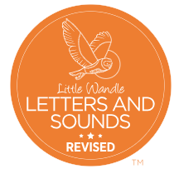  Tricky words – said, so, have, like, some, come, love, do, were, here, little, says, there, when, what, one, out, today | Mathematics:  In Maths we will be using NCETM for the number aspect of our learning and the White Rose Scheme for our topic Maths.    Week 1 – Cardinality, ordinality and counting  Week 2 – Subitising  Week 3 – Composition  Week 4 – Composition  Week 5 _ Comparison    Exploring 3D shapes | Understanding the World:  - Describe some ways that plants or animals should be cared for in order for them to survive. Looking after animals.  - Identify common features for different groups of animals, including wild and domestic animals. Meet the animals.  - Display the Scales, feathers and fur picture cards alongside a variety of feathers, furry and scaly fabric for the children to explore and discuss. Ask the question, 'How do you think the animals feel?' Scales, fur and feathers.  - Match animals to their young. Display the Animals and their babies picture cards for the children to explore and match together.  - Describe how the weather, plants and animals of one place is different to another using simple geographical terms. Animals around the world.  - Observe and describe living things and their habitats within the local environment. Minibeast Safari  - Represent scientific observations by mark making, drawing or creating simple charts and tables. Offer explanations for why things happen, making use of vocabulary, such as, because, then and next. Looking after nature.  - Identify common features for different groups of animals, including wild and domestic animals. Same and different.  - Draw a minibeast and label its body parts.
Communication and Language:  Listen and understand instructions while busy with another task.  Maintain activity while listening.  Understand how, why, where questions.  Describe events in some detail.  Express ideas about feelings and experiences.  Articulate their ideas and thoughts in well-formed sentences.  Use language to reason.  In English we will be looking at the book The lion inside by Rachel Bright. This is a story about a tiny, meek mouse who finds it tough being so small. He decides it is time to make a change so that the other animals will notice him and be his friend. We will also be using the book Omar, the bees and me by Helen Mortimer. This is a story about a little boy called Omar and a little girl called Maisie. One day for show and tell, Omar brings in a small slice of honey cake that reminds him of his beekeeping grandpa. It gives Maisie and the whole class an idea to make their town more bee-friendly  By creating a bee corridor.  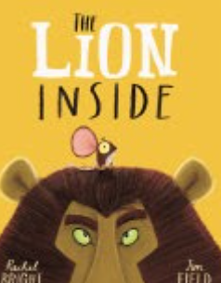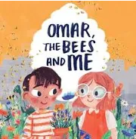 | Reception Summer Term 1 | PSHE:  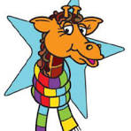  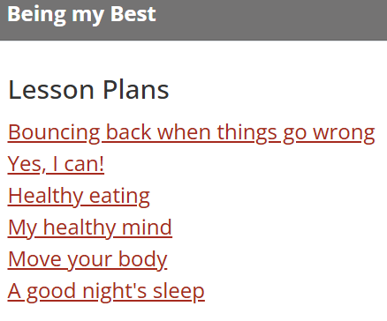
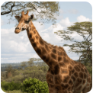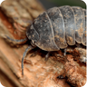
Animal Safari Creep, crawl and wriggle
 | Physical Development:  Combine different movements with ease and fluency  Develop the foundations of a handwriting style which is fast, accurate and efficient.  PE: Mr Treble  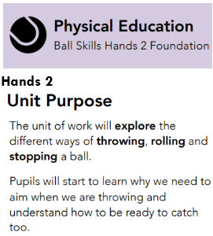   | RE:  Emmanuel Project  What makes every single person unique and precious?  This unit lays foundations for understanding the Christian belief that all humans are made in the image of God, each an  ‘incarnation’, a physical being known and loved by him.  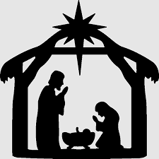  
Expressive Arts and Design:
- Communicate their ideas as they are creating artwork. Feathered friends.
- Discuss similarities and differences in their own and others' work, linked to visual elements, such as colour, scale, subject matter, composition and type. Animal patterns.
- Rainforest animals.
- Display the Animal mask templates with different coloured fabric capes or tabards for the children to dress up and act out a role or create animal stories in their play. The children might like to wear the masks they made as they play.
- Create collaboratively, share ideas and use a variety of resources to make products inspired by existing products, stories or their own ideas, interests or experiences. Animal homes.
- Set up large weaving frames outdoors on railings or use old bicycle wheels. Offer coloured wool and floristry ribbon for the children to weave and create patterns. Wonderful webs
- Butterfly printing
- Display the Butterfly picture cards, Butterfly templates, a selection of leaves, flower petals and glue for the children to create symmetrical butterflies using the natural resources.
- Use primary and other coloured paint and a range of methods of application. Add oval-shaped pebbles and ready-mixed paint in the creative area for the children to make minibeast pebble art.
- Provide play dough, googly eyes, matchsticks, pipe cleaners and craft pompoms for the children to create model minibeasts.

In Music we follow the programme It’s oh so quiet and slap clap clap.This term we will be learning about dynamics, timbre, musical story telling, music and 3 time and beat.



