Literacy and Reading:  When guided reading we will focus on decoding, prosody (reading with expression) and comprehension. Each week children will bring home a library book to share and enjoy with you and their guided reading book to  practise at home.  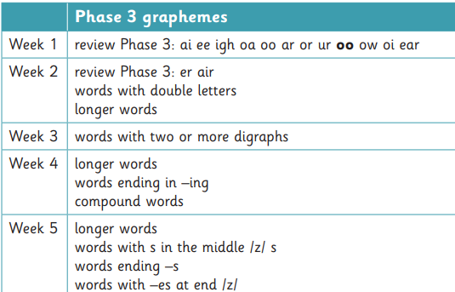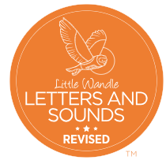  Revise Tricky words – was, you, they, my, by, all, are, sure, pure | Mathematics:  In Maths we will be using NCETM for the number aspect of our learning and the White Rose Scheme for our topic Maths.    Week 1 – Counting, ordinality and cardinality  Week 2 – Comparison  Week 3 – Composition.  Week 4 – Composition  Week 5 _ Composition    Length, Height and Time  Building 9 and 10  Exploring 3D shapes | Understanding the World:  - Observing and describing living things and their habitats within the local environment.  - Caring for growing seeds and plants and describe observable features of different types of plants and trees.  - Naming and describing basic features of plants and trees. Growing beans.  - With support, observe, record and talk about materials and living things. Fill a tuff tray with various seeds to explore.  - Match animals to their young.  - Record data in simple tables, pictograms or block charts. ‘Which animal is the most popular?'  - Put a range of fruit in a glass or clear plastic cloche. Leave it over time so the children can observe what happens to the fruit as it decays. Take photographs to document the changes.  - Describe some similarities and differences between things in the past and the present. Farms in the past.
Communication and Language:  Children will be learning about why listening is important. They will be learning to maintain attention in different contexts.  In English we will be looking at the book ‘The Extraordinary Garden’ by Sam Boughton. This is a story about a boy called Joe who lives in a very grey world. One day, Joe has an idea and plants a tiny apple seed, changing his world from ordinary to extraordinary. We will also be using the book Tad by Benji Davies. This is a story of a tiny tadpole who lives in a pond with her tadbrothers and tadsisters. Tad is worried about what has happened to them, and then one day, Big Blub comes and chases her. Will she manage to escape?  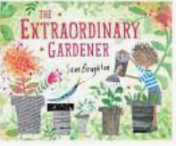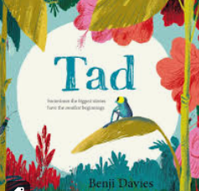 | Reception Spring Term 2 | PSHE:  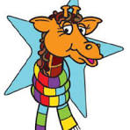  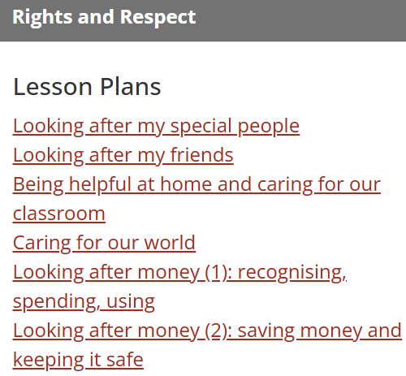
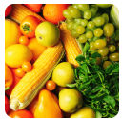
Ready Steady Grow Signs of Spring
 | Physical Development:  Know and talk about the different factors that support their overall health and wellbeing: regular physical activity, healthy eating, toothbrushing, sensible amounts of ‘screen time’, having a good sleep routine, being a safe pedestrian.  PE:  Mr Treble  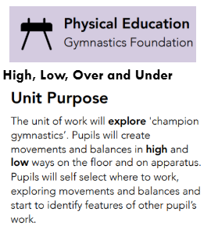  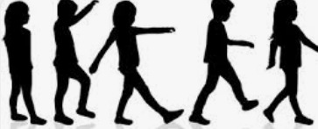 | RE:  Emmanuel Project  ‘Why do Christians put a cross in an  Easter Garden?’  This unit lays foundations for  understanding that Christians believe  Jesus died on a cross to rescue humanity  from the sin which cuts them off from God.  Christians believe Jesus was raised from  death and offers them forgiveness of sin  and new life with him in heaven. The cross symbolises these beliefs.  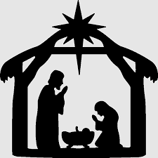  
Expressive Arts and Design:
Exploring colour and application of paint using a range of different tools. Adapting and refining their work as they are constructing and making.
Making seed shakers.
Collaged farms from aerial pictures.
Explore artwork by the famous artist Giuseppe Arcimboldo – pictures in the style of.
Select appropriate materials when constructing and making. Making nests.
Display daffodils at different stages with some in bud, and some in full bloom. Cut one of the daffodils in half so the children can see inside the flower. Provide hand lenses for the children to explore the daffodils.

In Music we follow the programme Up and Down and Five fine bumble bees.This term we will be learning about pitch contour, timbre, tempo, structure and active listening.



