

TA of the Year 2017

Dear Parent,
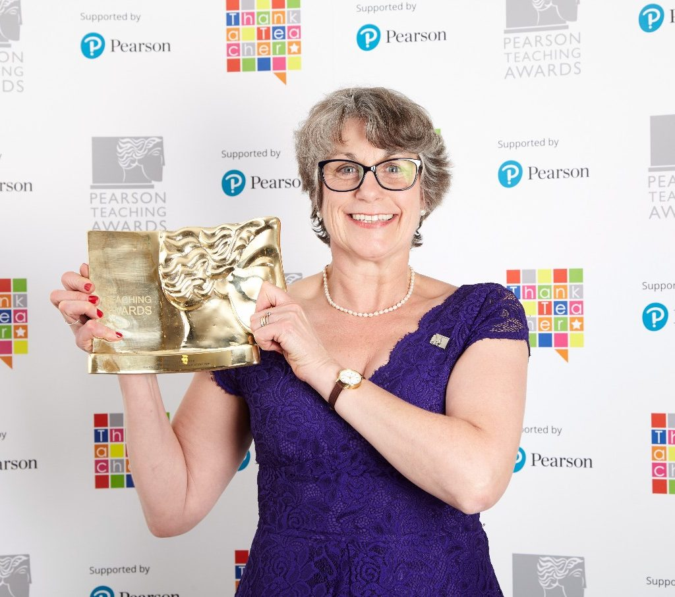
On the last Sunday of the ½ term break you may have watched the Pearson Education Awards on the BBC. If you did you would have seen that Mrs Downes was the winner of the National TA of the Year Award.

We are all delighted that Mrs Downes has been awarded such a prestigious award. It was fully deserved and a rich recognition of the tremendous work that Mrs Downes does here at Puddletown. She has helped so many children who love working with her, she also provides much to her colleagues.

We are blessed at Puddletown First School to have such high calibre staff supporting our children. Mrs Downes really does epitomise the dedication, passion and commitment that all our staff demonstrate every day of every week.

I apologise that this letter has been delayed but as you may know sadly I was unable to be in school last week but I am sure that you would want to add your congratulations to Mrs Downes

Yours sincerely,

D Hunwick

